Read Across America Week

Read Across America is a day held annually on March 2nd that encourages children in every community to read and also encourages parents and teachers to celebrate the joy of reading. It’s a holiday that has been celebrated since 1998 and falls on the same day as children’s book author Dr. Seuss.

This year at Clarksville we are kicking off Read Across America on March 1st. Teachers are decorating their doors all about a favorite book, and students will meet with their buddy to read together for 20 minutes. But the fun doesn’t stop there, we will be celebrating Read Across America the following week as well. Each day there is a fun and creative way to dress.

March 4, 2019 | March 5, 2019 | March 6, 2019 | March 7, 2019 | March 8, 2019
Rainbow Day  Wear as many colors as possible. | Dress as your favorite literary character. | Wacky Wednesday | Wear Red and White | Inside Out Day  Wear your clothes inside out.

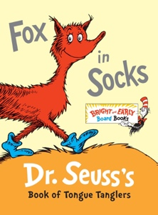
One favorite Dr. Seuss book is Fox in Socks. We were inspired by this book and are hosting a sock donation drive. We are looking for new pairs of socks to deliver to Grassroots. There will be a collection bin in the front hallway from March 1st - 8th. Our goal is to collect at least 200 pairs of socks by the end of the week. All socks will be donated to the Grassroots organization and help individuals in our community.

We hope you and your child have fun during this week and take the time to celebrate the joy of reading together!

