|  |  |  |
| --- | --- | --- |
| Clarksville Elementary School | **12/1/2021** | Winter Edition |

Cougar news

|  |
| --- |
| **UPCOMING DATES:**  **December 6th – 10th – Inclusive School Week**  **December 9th – Hearing & Vision Screening**  **December 14th – PTA Meeting**  **December 15th – Schools Close 3 hrs early for Students**  **December 16th – Hearing and Vision Re-screening**  **December 22nd – Spirit Day – PJ Day**  **December 23rd – January 2nd - Winter Break; Schools and Offices Closed** |
| **CONTACT US:**  **CES Front Office: 410-313-7050 Fax: 410-313-7054**  **CES Health Room: 410-313-7107 Fax: 410-531-2705** |

Retirement Announcement: Mrs. Crivelli

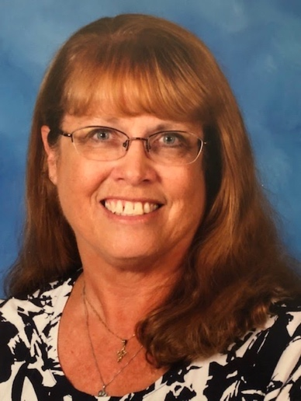Mrs. Carol Crivelli, one of our school’s Paraeducators, will be retiring at the end of December. Mrs. Criveilli has been at Clarksville Elementary school for the past 20 years. She has been a paraeducator in Media, ESOL, 5th, 4th, 3rd, and is currently working in Kindergarten. She works with many children doing lunch and recess duties and holding ELA and math support groups. She is a dedicated member of our school community and will be greatly missed. Please join us in wishing Carol all the best in her retirement.

Inclusive School Week – December 6th – 10th

Inclusive Schools Week is an annual international event celebrated the first full week in December to acknowledge schools and communities' continued journey toward providing quality education to all children regardless of differences in ability, gender, ethnicity, language, and health status. Adapted From: [www.inclusiveschools.org](https://inclusiveschools.org/); you may access the website for information and resources.



Next week, teachers will engage students in different activities as we continue to recognize all students as full members of our school communities. We hope that you will join us in celebrating this week by discussing these activities with your child.



Happy Holidays to all!

I hope this newsletter reaches you in good health and festive spirits. December has arrived and with that comes colder temperatures as well as preparation for the family traditions that each one of us looks forward to each and every year. Our winter break will start in three weeks…..wherever your plans take you I hope you take the time with family and friends to reconnect and rejuvenate.

The hustle and bustle has begun at CES. Within this month, we have celebrated our annual Turkey Trot and will be gearing up for Inclusive Schools Week. We want to thank all of our CES families, staff, and students who make these events such great successes. We are truly fortunate and grateful to have such a caring, supportive school community at CES. These events would not be possible without our generous CES families, staff, and students to coordinate and support them.

Please be sure to remind your children to dress appropriately for the colder weather, since we will continue to have recess and go outside whenever possible. Also, we have many lost articles of clothing in our lost and found. Please be sure to have your child check it out if they have lost an item.

We want to personally thank all of our parents and families who came to our November parent-teacher conferences. We appreciate your support and time in valuing your child’s education. We are very proud of our students and their accomplishments. Also, we are so grateful to our very own CES PTA that provided a fabulous breakfast spread for our CES staff…..what a fantastic treat for us!

On behalf of all of our CES staff, we hope you enjoy this holiday season with family and friends. Thank you for sharing your children with us each day, they are a joy to teach and learn from! We wish you good health and wellness for 2022! Happy New Year!

Warm Regards,

Ms. Malcotti

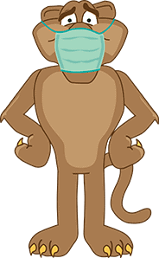**Front Office**

Howard County public schools require masks for all students, staff and visitors in school buildings during the 2021-2022 academic year regardless of their vaccine status. **Reminder:** **All visitors to the school must wear their mask while waiting in the school vestibule or coming into the building.**

**EARLY DISMISSALS**

FRIENDLY REMINDER: If you need to take your student out for an early dismissal in the late afternoon, **you need to be at the school to pick them up prior to 3:30pm**. After that time, it gets very busy with CES Afternoon dismissal that we can’t accommodate requests to find a student after 3:30pm. If a parent comes after 3:30pm, you will be directed to the CAR RIDER line. Thank you for honoring this policy.

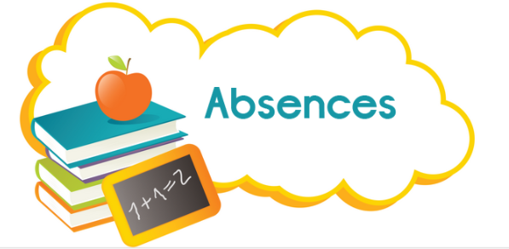**Do you need to report your child's absence?** Clarksville Elementary has an email address dedicated to reporting your student's absences. If your child will miss class for any reason, please use [**CESAbsence@hcpss.org**](mailto:CESAbsence@hcpss.org) to inform us.  This mailbox will be monitored by front office staff so please include the following information:

1. Your child's first and last name
2. Grade
3. Homeroom teacher
4. The dates your child is absent
5. The reason for the absence (if it is an illness, please list the symptoms so we can inform the health room)

**CHANGE IN DISMISSALS**

If you have to change your student’s dismissal, please email or send a note to the teacher. If you have to make the change during the day after your student has come to school, **please email the teacher and call the front office on or before 2pm.**

**CES Spirit Day**

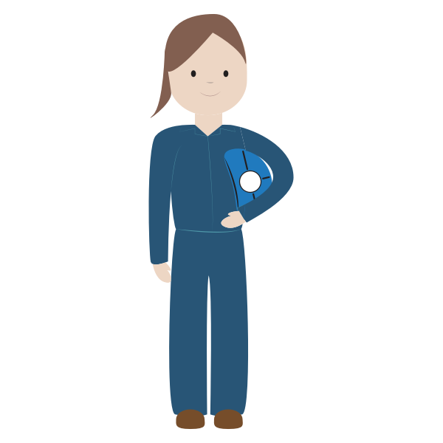PJ Day

Grab your favorite, comfy, cozy pajamas and dream the day away.

Wednesday, December 22, 2021

Tweet us @hcpss_ces

**Technology**

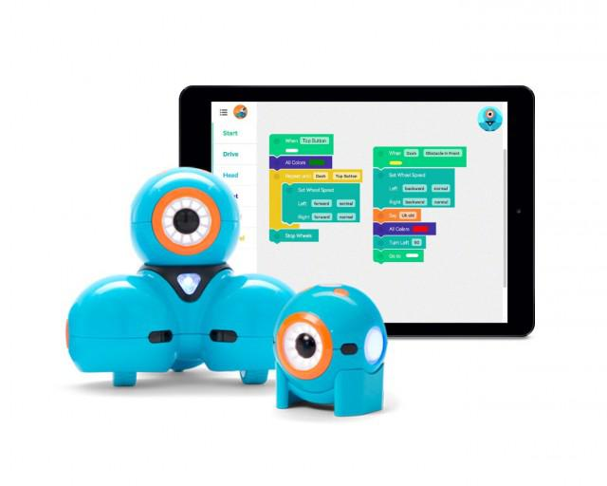 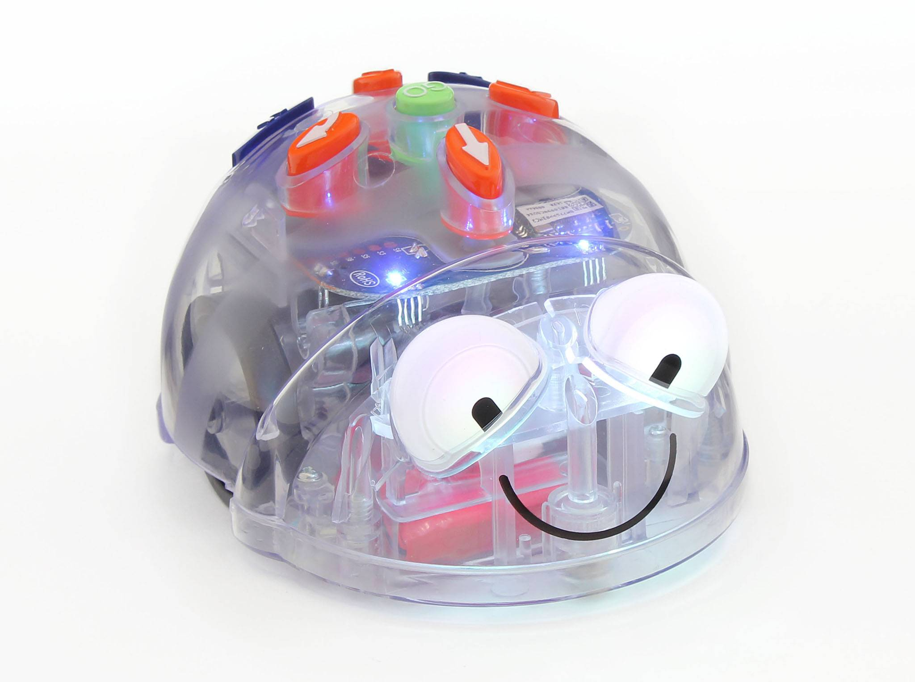

**Computer Science Education Week** and the **“Hour of Code”** is Dec. 6 – 12! During this special week, students in every grade will have the opportunity to participate in fund coding challenges during Technology class. PLUS, we don’t stop at just 1 hour of coding! Every grade level has a high-quality Computational Thinking (coding) unit as part of their HCPSS Technology curriculum. Want to help your child code at home? Check out <https://code.org/learn> for a variety of games designed for children of all ages & skills levels.

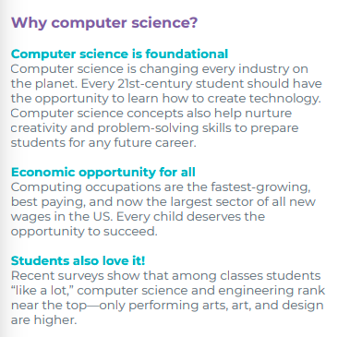

Image from: <https://hourofcode.com/files/hoc-one-pager.pdf>

**Media**

**Attention 5th Graders!  Battle of the Books is back for 2022!**

**Dates to Remember:**

**Dec 2, 3, & 4, 2021**

Curbside pickup of books

**Feb. 7, 2022** Permission forms due

**Dates TBD March 2022** Mandatory Logistics Meetings via Zoom

Questions: [donna_britton@hcpss.org](mailto:donna_britton@hcpss.org) or contact the Howard County Library

**Message from Rainbow Representative**

**Read the Rainbow with Justin Richardson and Peter Parnell**

**Join us virtually on Saturday, January 8th 2022 @ 1:00pm**

**to meet author team Justin Richardson and Peter Parnell, who will read and discuss their book, *And Tango Makes Three***

**This is a FREE bookclub and open to ALL (students,**

**parents, educators, and community members).**

**The first 50 families registering with preschool and/or**

**elementary aged children will receive a free copy of**

**the book!**

**To join, please complete the following registration form:** [**https://forms.gle/Q7W1tcH1eNUbNsKUA**](https://forms.gle/Q7W1tcH1eNUbNsKUA)

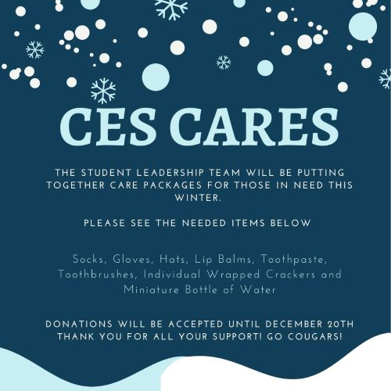

**Health**

**Vision and Hearing Clinic being held at CES on 12/9; Re-screening on 12/16**

The Howard County Health Department and HCPSS School Health Services support your student's academic success by providing vision and hearing screenings at your child's school. These screenings are required by Maryland State Law.

**Screenings are provided to the following students:**

* Students in Kindergarten, 1st and 8th grades
* All students K-8 new to the state of Maryland that do not have a record of prior vision and hearing screening within the last 12 months
* High School students enrolling in the public school system in the United States for the first time

**If your child has glasses, please make sure that he or she wears them on the screening day.**

Your child will receive these screenings unless you object for religious reasons. Please send a letter to your child's school health room if you choose to opt out of the Health Department screenings.

If your child does not pass either the vision or hearing screen, you will receive a letter from his or her school notifying you of this result. It is then recommended that you take your child to have his or her vision evaluated by an eye care specialist or that you contact your child's medical provider for a referral to an audiologist for a complete hearing evaluation.

A vision screening does not take the place of a comprehensive eye exam.

Should you have any questions, please contact your school nurse or the Vision and Hearing Program Supervisor at 410-313-7210. If you need information about the Maryland Children's Health Insurance Program, please contact the Howard County Health Department at 410-313-5845.

**Volunteering**

**Volunteer Procedure for HCPSS:**

Effective immediately, all volunteers and chaperones who interact with students, and parents/guardians who are conducting classroom observations will be required to use the **PinPoint platform** to show proof of full vaccination at least five school days in advance.

**Use the PinPoint Vaccine Check platform to verify your vaccination status.** The following information will be required during the process:

* **The school(s) you will enter during the school day during the 2021-2022 school year**. You should only use this platform once. If you need to enter an additional school later in the year, please notify school_volunteers@hcpss.org.
* **CDC COVID-19 Vaccination Record Card**: Uploading your COVID-19 vaccination card is *not a requirement* of the PinPoint system. If you experience issues uploading your card, please select the “I do not have my card” option and proceed with the VaccineCheck verification process.
* Vaccination dose date(s):
  + If you do not know the date(s) you received the vaccine, you will still be able to verify your vaccination status by providing additional information.
  + If you got vaccinated in Maryland, consider accessing Maryland MyIR to view your “Certification of COVID-19 Vaccination” document which includes your dose dates.
* **Photo**: The platform will ask you to upload a photo of yourself for your digital vaccine card. *This is optional*.
* **Registration Number:** The platform will provide you with a registration number at the end of the process. Please write down or screenshot the number so you can use it if you wish to download your digital vaccine card once available, **which is optional**. Receiving your digital vaccine card is not a requirement for entry to the school.

If you have questions about how to use the platform, please contact PinPoint’s support team by emailing [hcpss@pinpoint.us](mailto:hcpss@pinpoint.us) or calling 888-750-2247.

**Additionally, you need to take the training course(s) to volunteer:**

**Confidentiality Training Course for Volunteers**

Thank you for your interest in volunteering within the Howard County School System! We value our volunteers and the contributions they make to our students and schools.

According to HCPSS Board Policy, all parent volunteers must complete a Confidentiality Training Course about protecting the privacy of our students, staff, and schools.

[View the brief training presentation and print out a certificate of completion](http://www.hcpss.org/parents/volunteer-information/)

**Child Abuse and Neglect Training Course for Volunteers**

This training is required for new parent chaperones before attending a school field trip.

* View the Maryland State Law and HCPSS Policy 1030 [Training Presentation](http://www.hcpss.org/f/employees/childabuse_ppt.pdf)
* [Print off the certificate of completion](http://www.hcpss.org/f/parents/abuse_certificate.pdf) and hand it in at the front office

\***All volunteers who interact with students will be required to show proof of full vaccination in order to be in or outside of the school.**